MEETING AGENDA

Topic:

Thursday, March 5, 2020

10:30-11:30

Attendees: (All Team Members)

Please bring:

10:30 | Hardware Review 2  Assign Roles for memo  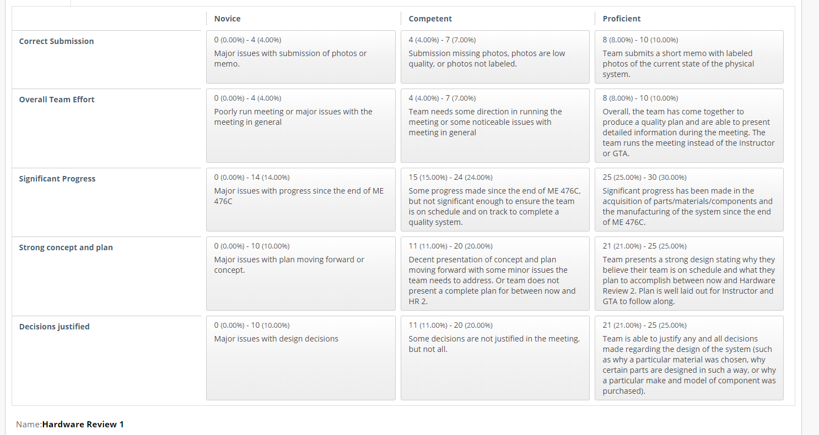
10:45 | UGRAD Registration  Review requirements and choose time if necessary  Review Poster assignment requirements
10:55 | Individual Analysis Discussion  Discuss each team member’s analysis topic
Remaining minutes | Form Knee Brace

